Q1: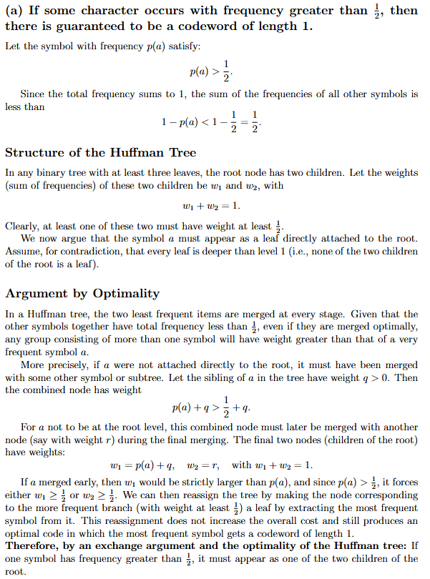
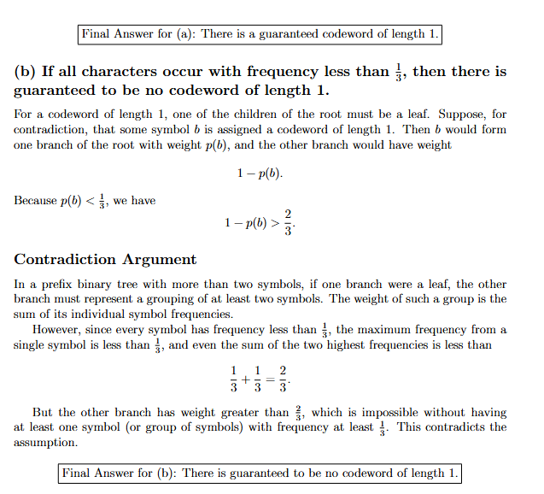

Q2:
#include <iostream>
#include <string>
#include <vector>
#include <queue>
using namespace std;

class Node {
public:
int data;
Node* left;
Node* center;
Node* right;
Node(int x) : data(x), left(nullptr), center(nullptr), right(nullptr) {}
};

class Compare {
public:
bool operator()(Node* a, Node* b) {
return a->data > b->data;
}
};

void preOrder(Node* root, vector<string>& ans, string curr) {
if (!root) return;

if (!root->left && !root->center && !root->right) {
ans.push_back(curr);
return;
}

preOrder(root->left, ans, curr + '0');
preOrder(root->center, ans, curr + '1');
preOrder(root->right, ans, curr + '2');
}

vector<string> huffmanCodes(string s, vector<int> freq) {
int n = s.length();
priority_queue<Node*, vector<Node*>, Compare> pq;

for (int i = 0; i < n; i++)
pq.push(new Node(freq[i]));

// Adjust number of nodes so that (n - 1) % 2 == 0
while ((pq.size() - 1) % 2 != 0)
pq.push(new Node(0));

while (pq.size() > 1) {
Node* l = pq.top(); pq.pop();
Node* c = pq.top(); pq.pop();
Node* r = pq.top(); pq.pop();

Node* newNode = new Node(l->data + c->data + r->data);
newNode->left = l;
newNode->center = c;
newNode->right = r;

pq.push(newNode);
}

Node* root = pq.top();
vector<string> ans;
preOrder(root, ans, "");
return ans;
}

int main() {
string s = "abcdef";
vector<int> freq = {5, 9, 12, 13, 16, 45};

vector<string> ans = huffmanCodes(s, freq);

cout << "Ternary Huffman Codes:\n";
for (int i = 0; i < s.size(); i++) {
cout << s[i] << ": " << ans[i] << endl;
}

return 0;
}

Q3:
#include <iostream>
#include <string>
#include <vector>
#include <queue>
using namespace std;

class Node {
public:
int data;
Node* left;
Node* center;
Node* right;
Node(int x) : data(x), left(nullptr), center(nullptr), right(nullptr) {}
};

class Compare {
public:
bool operator()(Node* a, Node* b) {
return a->data > b->data;
}
};

void preOrder(Node* root, vector<string>& ans, string curr) {
if (!root) return;

if (!root->left && !root->center && !root->right) {
ans.push_back(curr);
return;
}

preOrder(root->left, ans, curr + '0');
preOrder(root->center, ans, curr + '1');
preOrder(root->right, ans, curr + '2');
}

vector<string> huffmanCodes(string s, vector<int> freq) {
int n = s.length();
priority_queue<Node*, vector<Node*>, Compare> pq;

for (int i = 0; i < n; i++)
pq.push(new Node(freq[i]));

// Adjust number of nodes so that (n - 1) % 2 == 0
while ((pq.size() - 1) % 2 != 0)
pq.push(new Node(0));

while (pq.size() > 1) {
Node* l = pq.top(); pq.pop();
Node* c = pq.top(); pq.pop();
Node* r = pq.top(); pq.pop();

Node* newNode = new Node(l->data + c->data + r->data);
newNode->left = l;
newNode->center = c;
newNode->right = r;

pq.push(newNode);
}

Node* root = pq.top();
vector<string> ans;
preOrder(root, ans, "");
return ans;
}

int main() {
string s = "abcdef";
vector<int> freq = {5, 9, 12, 13, 16, 45};

vector<string> ans = huffmanCodes(s, freq);

cout << "Ternary Huffman Codes:\n";
for (int i = 0; i < s.size(); i++) {
cout << s[i] << ": " << ans[i] << endl;
}

return 0;
}

Q4:
#include <iostream>
#include <vector>
#include<algorithm>
#include <iomanip>
using namespace std;

// Custom sort function to sort contestants on basis of larger (bike+run times),
//in other words an alternate of finish time as used for sorting in activity selection problem
void sortContestants(vector<vector<double>>& contestants)
{
int n = contestants.size();
bool swapped;

for (int i = 0; i < n - 1; i++)
{
swapped = false;
for (int j = 0; j < n - i - 1; j++)
{
// Sort in descending order by (bike + run)
if (contestants[j][1] + contestants[j][2] < contestants[j + 1][1] + contestants[j + 1][2])
{
swap(contestants[j], contestants[j + 1]);
swapped = true;
}
}
if (!swapped)
break;
}
}

// Function to schedule and calculate total completion time
void scheduleTriathlon(vector<vector<double>>& contestants)
{
double currentSwimEnd = 0;
double totalCompletion = 0;

for (int i = 0; i < contestants.size(); i++)
{
double swim = contestants[i][0];
double bike = contestants[i][1];
double run = contestants[i][2];

double startSwim = currentSwimEnd;
double finishSwim = startSwim + swim;
double finishTotal = finishSwim + bike + run;

currentSwimEnd = finishSwim; // next contestant starts swimming after this
totalCompletion = max(totalCompletion, finishTotal);

cout << "Contestant " << i + 1 << " finishes at time: " << finishTotal << endl;
}

cout <<endl<< "Total competition ends at time: " << totalCompletion << endl;
cout << "======================================" << endl;
}

//Function to print order of starting contestants
void optimalSchedule(vector<vector<double>>& contestants)
{
cout << fixed << setprecision(2);
cout << "===== Optimal Triathlon Schedule =====" << endl;
cout << "Order of contestants (Swim, Bike, Run):" << endl;

for (int i = 0; i < contestants.size(); i++)
{
cout << i + 1 << ". (" << contestants[i][0] << ", "
<< contestants[i][1] << ", " << contestants[i][2] << ")" << endl;
}

cout <<endl<< "Individual Finish Times:"<<endl;
}
int main()
{
vector<vector<double>> contestants =
{
// Each vector = { swim, bike, run }
{3, 10, 8},
{6, 4, 5},
{2, 9, 7},
{5, 3, 2}
};
sortContestants(contestants);
optimalSchedule(contestants);
scheduleTriathlon(contestants);

return 0;
}

Q5:
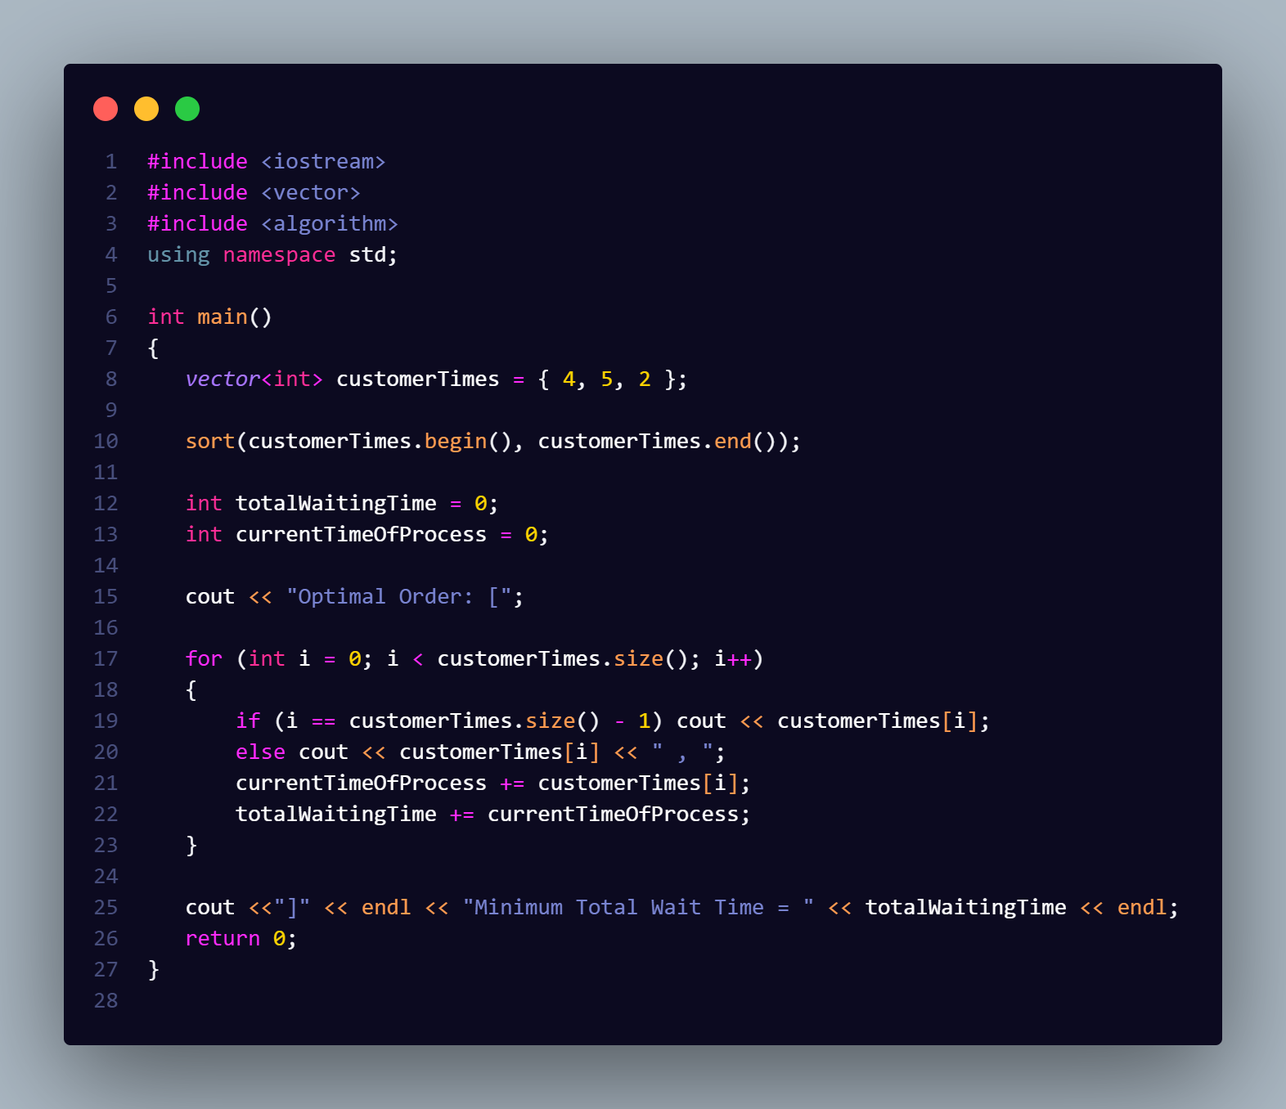

Q6:
#include <iostream>
#include <vector>
#include <algorithm>
using namespace std;

void sortCustomers(vector<vector<double>>& Customers)
{
int n = Customers.size();
bool swapped;
for (int i = 0; i < n - 1; i++)
{
swapped = false;
for (int j = 0; j < n - i - 1; j++)
{
if (Customers[j][3] > Customers[j + 1][3])
{
swap(Customers[j], Customers[j + 1]);
swapped = true;
}
}
if (!swapped)
break;
}
}

int main()
{
vector<vector<double>> Customers =
{
{1, 4, 2,0}, // 1st index stores customer's ID
{2, 5, 1,0}, // 2nd index stores customer's Time
{3, 2, 3,0}, // 3rd index stores customer's Priority
{4, 3, 2,0} // 4th index will be used to store customer's Time to Priority Ratio
};

for (int i = 0; i < Customers.size(); i++)
Customers[i][3]=Customers[i][1] / Customers[i][2]; //calculating customer's Time to Priority Ratio

sortCustomers(Customers); // sort customers based on thier Time to Priority Ratio

double totalWait = 0;
double currentTime = 0;

cout << "Optimal Order: [";

for (int i = 0; i < Customers.size(); i++)
{

if (i == Customers.size() - 1) cout << Customers[i][0];
else cout << Customers[i][0] << " , ";
currentTime += Customers[i][1];
totalWait += currentTime;
}

cout << "]" << endl << "Minimum Total Wait Time = " << totalWait << endl;
return 0;
}

